Long Base Neutrino Facility (LBNF) Conceptual Design Report

Volume 3—Copy

Date: | May 8, 2015—Copy for Vaia’s team
Volume: | 3
Version: | 1

CHANGE LOG
This version of the document may not be the most current approved revision. The current revision is maintained in the Project’s Document Management system (DocDB), where all internal Project document approvals are managed. The current approved version is always available in the DocDB. This document will be reviewed and updated annually or as needed. The Configuration Manager (or Document Manager) is responsible for maintaining an up-to-date version and obtaining required signatures.

Release No. | Date | Revision Description

Contents
APPROVALs and signatures ii
CHANGE LOG iii
ABBREVIATIONS AND ACRONYMS x
LIST OF TABLES xi
LIST OF FIGURES xiii
1 Overview 16
1.1 Introduction 16
1.2 Executive Summary 16
1.3 Project Management 16
1.3.1 Overview 16
1.3.2 LBNF Project Partners 17
1.3.2.1 Fermilab 17
1.3.2.2 South Dakota Science and Technology Authority and SURF 17
1.3.2.3 CERN 18
1.3.3 Internal Management Boards 18
1.3.3.1 LBNF Project Management Board 18
1.3.3.2 (other technical and advisory committees at L2?) 18
1.3.4 External Advisory Committees 18
1.3.5 Coordinating Committees 18
1.3.6 Work Breakdown Structure 18
2 Beamline 20
2.1 Overview 20
2.1.1 Scope 21
2.1.2 Physics Reach with the Reference Design 22
2.1.3 Reference 23
2.2 PRIMARY BEAM (WBS 130.02.02) 23
2.2.1 Introduction 23
2.2.1.1 Design Consideration 24
2.2.1.1.1 Length and Elevation 24
2.2.1.1.2 Existing Infrastructure and Shielding 24
2.2.1.1.3 Beam Control 24
2.2.1.2 Reference Design Overview 24
2.2.2 Lattice Optics (WBS 130.02.02.07) 25
2.2.2.1 Overview 25
2.2.2.2 Optics 25
2.2.2.2.1 Corrections 25
2.2.2.2.2 Low Loss 26
2.2.3 Magnets (WBS 130.02.02.02) 26
2.2.3.1 Introduction 26
2.2.3.2 Design Considerations 27
2.2.4 Magnet Power Supplies (WBS 130.02.02.03) 27
2.2.4.1 Introduction 27
2.2.4.2 Design Considerations 28
2.2.4.3 Reference Design 28
2.2.4.3.1 Power-supply Loops 28
2.2.4.3.2 Power Supply Topology 28
2.2.5 Primary Water System (WBS 130.02.02.04) 29
2.2.6 Beam Instrumentation (WBS 130.02.02.05) 29
2.2.7 Primary Vacuum (WBS 130.02.02.06) 29
2.2.7.1 Introduction 29
2.2.7.2 Design Considerations 30
2.2.8 Magnet Installation 30
2.3 Primary Beam Loss Calculations 31
2.4 Neutrino Beam (WBS 130.02.03) 31
2.4.1 Introduction 31
2.5 Targetry (WBS 130.02.03.03) 32
2.5.1 Baffle and Target 33
2.5.2 Module and Carrier 34
2.6 Horns (WBS 130.02.03.04) 35
2.6.1 Horn Focusing system 35
2.6.2 Horn Support Module 38
2.7 Horn Power Supplies (WBS 130.02.03.05) 38
2.7.1 Horn Power Supply 38
2.7.2 Stripline 39
2.8 Target Hall Shielding (WBS 130.02.03.08) 39
2.8.1 Target Hall Shield Pile 39
2.8.2 Target Chase Cooling 39
2.9 Helium-filled Concentric Decay Pipe (WBS 130.02.03.06) 40
2.9.1 Decay Pipe Structure and Shielding 41
2.9.2 Downstream Decay Pipe Window 42
2.10 Beam Windows (WBS 130.02.03.02) 42
2.10.1 Primary Beam Window 43
2.10.2 Upstream Decay Pipe Window 43
2.10.3 Decay Pipe Helium Fill 44
2.11 Hadron Absorber (WBS 130.02.03.07) 44
2.11.1 Steady State Normal Operation 45
2.11.2 Accident Conditions 46
2.11.3 Steel Shielding Air Cooling 46
2.12 Remote Handling Equipment (WBS 130.02.03.11) 47
2.12.1 Target Complex Remote-Handling Facilities 47
2.12.2 Absorber Hall Remote Handling Facilities 48
2.13 RAW Water Systems (WBS 130.02.03.09) 49
2.13.1 Target Hall Systems 49
2.13.2 Absorber Hall Systems 49
2.14 Radiological Considerations 50
2.15 System Integration (WBS 130.02.04) 50
2.15.1 Introduction 50
2.15.2 Controls (WBS 130.02.04.02) 50
2.15.2.1 Introduction 50
2.15.3 Radiation-Safety Interlock Systems (WBS 130.02.04.03) 51
2.15.3.1 Introduction 51
2.15.4 Alignment (WBS 130.02.04.04) 51
2.15.4.1 Overview 51
2.15.4.2 Design Considerations 51
2.15.5 Installation Coordination 52
2.16 Alternatives 52
3 Conventional Facility Near Site (CFNS) 53
3.1 Overview 53
3.2 Existing Site Conditions 54
3.2.1 Surface Development, Topographic and Environmental Conditions 54
3.2.2 Overview of Site Geology 54
3.2.3 Overview of Site Groundwater Conditions 55
3.3 The Facility Layout 55
3.3.1 Project-Wide Considerations 56
3.3.1.1 Structure and Architecture for Surface Structures 56
3.3.1.2 Structure and Excavation for Underground Structures 57
3.3.1.3 Environmental Protection 58
3.3.1.4 Fire Protection/Life Safety Systems 58
3.3.1.5 Safeguards and Securities 59
3.3.1.6 Emergency Shelter Provisions 59
3.3.1.7 Energy Conservation 59
3.3.1.8 Construction Phasing 59
3.3.2 Project Site Infrastructure (WBS 130.06.02.05.02) 60
3.3.2.1 Roads and Infrastructure 60
3.3.2.2 Electrical 60
3.3.2.2.1 Pulsed Power System 60
3.3.2.2.2 Conventional Power System 61
3.3.2.3 Mechanical and HVAC 61
3.3.2.4 Plumbing and Cooling Systems 62
3.3.2.5 Data and Communications 62
3.4 New Surface Buildings 62
3.4.1 Primary Beam Service Building (LBNF-5) 62
3.4.1.1 Mechanical 63
3.4.1.2 Electrical 64
3.4.1.3 Plumbing 64
3.4.1.4 Fire Protection/Life Safety Systems 64
3.4.2 Target Hall Complex (LBNF-20) 64
3.4.2.1 Mechanical 66
3.4.2.2 Electrical 67
3.4.2.3 Plumbing 67
3.4.2.4 Fire Protection/Life Safety Systems 68
3.4.3 Absorber Service Building (LBNF-30) 68
3.4.3.1 Mechanical 69
3.4.3.2 Electrical 69
3.4.3.3 Plumbing 70
3.4.3.4 Fire Protection/Life Safety Systems 70
3.4.4 Near Detector Service Building (LBNF-40) 70
3.4.4.1 Mechanical 72
3.4.4.2 Electrical 72
3.4.4.3 Plumbing 72
3.4.4.4 Fire protection/Life Safety Systems 73
3.5 New Underground Structures 73
3.5.1 Beamline Extraction Enclosure and Primary Beam Enclosure 73
3.5.1.1 Mechanical 76
3.5.1.2 Electrical 76
3.5.1.3 Plumbing 76
3.5.1.4 Fire Protection/Life Safety Systems 77
3.5.2 Decay Pipe 77
3.5.2.1 Decay Region Geosynthetic Barrier System 78
3.5.3 Absorber Hall and Support Rooms 79
3.5.3.1 Grouting of the Rock Mass in the Decay/Absorber Region 80
3.5.3.2 Mechanical 80
3.5.3.3 Electrical 80
3.5.3.4 Plumbing 81
3.5.3.5 Fire Protection/Life Safety Systems 81
3.5.4 Near Detector Hall and Support Rooms 81
3.5.4.1 Mechanical 82
3.5.4.2 Electrical 83
3.5.4.3 Plumbing 83
3.5.4.4 Fire Protection/Life Safety Systems 83
4 Conventional Facilities Far Site (CFFS) 84
4.1 Overview 84
4.1.1 Surface Level Structures 84
4.1.2 Underground: Main Components 84
4.2 Existing Site Conditions 85
4.2.1 Existing Site Conditions Evaluation 87
4.2.1.1 Existing Facilities and Site Assessment 87
4.2.2 Evaluation of Geology and Existing Excavations 87
4.2.2.1 Geologic Setting 88
4.2.2.2 Rock Mass Characteristics: LBNF 88
4.2.2.3 Geologic Conclusions 89
4.3 Surface Facility 90
4.3.1 Existing Surface Facility 90
4.3.2 Surface Buildings 92
4.3.2.1 Cryogenic Compressor Building 93
4.3.2.2 Ross Dry 94
4.3.2.3 Ross Headframe and Hoist Buildings 95
4.3.2.4 Ross Crusher Building 95
4.3.3 New Surface Infrastructure 95
4.3.3.1 Roads and Access 95
4.4 Underground Excavation 95
4.4.1 LBNF Cavities 96
4.4.1.1 Structure and Cranes 98
4.4.2 LBNF Central Utility Cavern 98
4.4.3 Access/Egress Drifts 98
4.4.4 Excavation Sequencing 98
4.4.5 Interfaces between DUNE, Cryogenics and Excavation 99
4.5 Underground Infrastructure 99
4.5.1 Fire/Life Safety Systems 100
4.5.2 Shafts and Hoists 101
4.5.2.1 Ross Shaft 101
4.5.2.2 Yates Shaft 103
4.5.3 Ventilation 103
4.5.4 Electrical 104
4.5.4.1 Normal Power 104
4.5.4.2 Standby and Emergency Power 104
4.5.4.3 Fire Alarm and Detection 105
4.5.4.4 Lighting 105
4.5.4.5 Grounding 105
4.5.5 Plumbing 105
4.5.5.1 Industrial Water 106
4.5.5.2 Potable Water 106
4.5.5.3 Chilled Water 106
4.5.5.4 Fire Suppression 106
4.5.5.5 Drainage 106
4.5.5.6 Sanitary Drainage 107
4.5.5.7 Chilled Water 107
4.5.6 Cyberinfrastructure 107
4.5.7 Waste Rock Handling 108
5 Cryogenics infrastructure 110
5.1 Overview, Development Program, and ESH 110
5.2 Steel Cryostat 111
5.3 Membrane Cryostat 111
5.3.1 Sides and Bottom of Tank 111
5.3.2 Steel Frame and Vapor Barrier 112
5.3.3 Insulation System and Secondary Membrane 112
5.3.4 Tank Layers as Packaged Units 113
5.3.5 Top of Tank 114
5.4 Cryogenic Systems Layout 115
5.5 Cryogenic Systems Processes 118
5.5.1 Cryostat Initial Purge and Cool-down 121
5.5.1.1 Initial Purge 121
5.5.1.2 Water Removal via Gas Flow 121
5.5.1.3 Initial Cool-Down 121
5.5.1.4 Initial Purge and Cool-Down Design Features 122
5.5.2 Liquid Argon Receipt 122
5.5.2.1 Cryostat Filling 123
5.5.3 Argon Reliquefaction and Pressure Control 123
5.5.4 Argon Purification 125
5.5.5 Pressure Control 126
5.5.5.1 Normal Operations 126
5.5.5.2 Overpressure Control 126
5.5.5.3 Vacuum-Relief System 127
5.5.6 LN2 Refrigeration System 127

ABBREVIATIONS AND ACRONYMS
Modify and use the list below based on your project:

LIST OF TABLES
Table 1-1: WBS Chart to Level 3 18
Table 2-1: Summary of Principal Beam Design Parameters 20
Table 2-6: Horn Parameters. The Inner and Outer Conductor Parameters are Abbreviated by IC and OC, Respectively 36
Table 2-7: Summary of RAW skids heat loads for the Target Hall 49
Table 2-6: Alignment Tolerance Requirements (1) 52
Table 3-1: Primary Beam Service Building (LBNF-5) Electrical Power Loads 64
Table 3-2: Primary Beam Service Building (LBNF-5) Electrical Power Loads 67
Table 3-3: Absorber Hall and Absorber Service Building (LBNF-30) Electrical Power Loads 69
Table 3-4: Near Detector Hall and Near Detector Service Building (LBNF-40) Electrical Power Loads 72
Table 4-1: Environmental Design Criteria (Arup) 104
Table 5-1: Estimated Heat Loads within the Cryostat 124
Table 5-2: Important Pressure Values 126

This page is intentionally left blank.

LIST OF FIGURES
Figure 2-1: Longitudinal section of the LBNF beamline facility at Fermilab. The beam comes from the right, the protons being extracted from the MI-10 straight section of the MI. 20
Figure 2-1 Overview of the Primary Beamline 26
Figure 2-9: Schematic of the upstream portion of the LBNF neutrino beamline showing the major components of the neutrino beam. The target chase bulk steel shielding is shown mainly in green. Inside the target chase from right to left (the direction of the beam) pointing downwards: the beam window, horn-protection baffle and target mounted on a carrier, the two toroidal focusing horns and the decay pipe. Above the chase and to the right is the work cell for horn and target system repairs. The beige areas around the decay pipe indicate concrete shielding. The yellow and red lines indicate multi-ply geosynthetic barriers, separated by a drainage layer (blue). 31
Figure 2-10: Cross-section of LT Target for LBNF. The Alignment Rings do not run the Full Length of the Target 34
Figure 2-11: Target Carrier in Target Pile Shielding. The length of the baffle plus target assembly is shown in the fully inserted downstream position, and also in the furthest out position 2.5 m upstream of that. The extra 1000 mm length of a baffle for 2.4 MW operation is also sketched in, showing that the usable range of target motion may be modestly reduced by that upgrade. 35
Figure 2-12: Horn 1 Section. The reference “MCZERO” is the point along the beam that sets the coordinate system origin for Monte Carlo simulations. The red segment represents the target, of which, the upstream graphite segment is positioned 45 cms upstream of MCZERO. 36
Figure 2-13: Left: Conceptual Horn Stripline Block and Right: Horn Stripline Connection 37
Figure 2-14: LBNF Horn PS Simplified Circuit Diagram 38
Figure 2-15: Cross Section of Target Chase Steel Shielding (Cross-hatched Areas) 40
Figure 2-16: Schematic of the Target Pile and Decay Pipe Air-cooling Systems 40
Figure 2-17: Upstream Decay Pipe Window from NX Solid Model. The Central Part Indicate a Beryllium or a Beryllium-aluminum Alloy Section 43
Figure 2-18: Distribution of Total Power Deposited in the Central Part of the Absorber (See Figure 3-11). 45
Figure 3-1: Braced Excavation and Retaining Wall Systems with red dashed line showing the toe of the embankment 58
Figure 3-2: Primary Beam Service Building (LBNF-5) and Exterior Transformer Pad 63
Figure 3-3: Target Complex; Main Level Floor Plan 65
Figure 3-4: Target Hall/Chase Long Section 66
Figure 3-5: Absorber Service Building (LBNF-30) Floor Plan 68
Figure 3-6: Near Detector Service Building (LBNF-40) 71
Figure 3-7: Beamline Extraction Enclosure and Primary Beam Enclosure – Aerial View 74
Figure 3-8: Beamline Extraction Enclosure and Primary Beam Enclosure with Section A-A cut shown to show location of section shown in Figure 5 3 75
Figure 3-9: Primary Beam Enclosure Showing Technical Components –Typical Enclosure Section 76
Figure 3-10: Decay Pipe Cross Section 77
Figure 3-11: Geomembrane System Section View [from Outside (right) to Inside (left) in the Exploded View] 78
Figure 3-12: Absorber Hall Longitudinal Cross Section Cut along the Decay Pipe Centerline 80
Figure 3-13: Near Detector Plan View 82
Figure 4-1: Far Site: Main Components at the 4850 Level (Underground) 84
Figure 4-2: Regional Context showing the city of Lead, South Dakota. (Dangermond Keane Architecture, Courtesy Sanford Laboratory) 86
Figure 4-3: LBNF Core Locations and Geological Features 88
Figure 4-4: Contour of Stress Safety Factor Indicating Influences Between Caverns 90
Figure 4-5: Architectural Site Plan (HDR) 91
Figure 4-6: Ross Complex Architectural Site Plan (Arup) 92
Figure 4-7: Architectural Layout of LBNF Cryogenic Compressor Building 93
Figure 4-8: Photo of Ross Dry Exterior (HDR) 94
Figure 4-9: Location of New Command and Control Center (Sanford Lab) 94
Figure 4-10: Spaces Required for LBNF at 4850L (Sanford Lab) 96
Figure 4-11: Dimensions of the Main LBNF Cavern Excavations (final dimensions will be slightly smaller). (Sanford Lab) 97
Figure 4-12: Ross Shaft, Typical Shaft Set (SRK, Courtesy Sanford Laboratory) 102
Figure 4-13: Fiber Distribution System for LBNF (Arup) 107
Figure 4-14: Waste Rock Handling System Route (SRK, Courtesy Sanford Laboratory) 108
Figure 5-1: The Corrugated Stainless Steel Primary Barrier 111
Figure 5-2: Composite System as Installed for the LBNF Reference Design 112
Figure 5-3: Membrane Corner Detail 113
Figure 5-4: GST (Composite System from GTT) 114
Figure 5-5: Nozzle in Roof Membrane Cryostat (Figure Courtesy GTT) 115
Figure 5-6: The framing of the Ross shaft is shown on the left. The utility area in the upper right corner contains the piping associated with the cryogenic system 117
Figure 5-7: Isometric View of the Underground Cavern Layout 118
Figure 5-8: Cryogenic System Functions 119
Figure 5-9: Cryogenic System Block Flow Diagram 120
Figure 5-10: Liquid Argon Recondenser 124
Figure 5-11: Nitrogen Refrigeration-Plant Flow Diagram 128

Overview

Introduction
The global neutrino physics community is coming together to develop a leading-edge, dual-site experiment for neutrino science and proton decay studiesthe Deep Underground Neutrino Experiment (DUNE), hosted at Fermilab in Batavia, IL. The facility required for this experiment, the Long-Baseline Neutrino Facility (LBNF), will be an internationally designed, coordinated and funded program, comprising the world's highest-intensity neutrino beam at Fermilab and the infrastructure necessary to support DUNE's massive, cryogenic far detectors installed deep underground at the Sanford Underground Research Facility (SURF), 800 miles (1,300 km) downstream, in Lead, SD. LBNF will also provide the facilities to house the experiment's near detectors on the Fermilab site. LBNF and DUNE will be tightly coordinated as DUNE collaborators design the detectors that will carry out its experimental program.

The LBNF scope includes the following items:
- an intense neutrino beam aimed at a far site
- conventional facilities at both the near and far sites
- cryogenics infrastructure at the far site to support the DUNE liquid argon time-projection chamber (LArTPC) detector

Beamline

Overview
The LBNF beamline at Fermilab is being designed to provide a neutrino beam of sufficient intensity and appropriate energy range to meet the goals of the DUNE experiment with respect to long-baseline neutrino-oscillation physics. It aims at a wide band neutrino beam about 1,300 km away, toward detectors 4850 ft underground, placed at the SURF Facility in South Dakota. The design is a conventional beamline, with horn-focused, sign selected neutrino beam. The components of the beamline are being designed to extract a proton beam from the Fermilab Main Injector (MI) and transport it to a target area where the collisions generate a beam of charged particles. This secondary beam, aimed toward the Far Detector, is followed by a decay-pipe where the particles of the secondary beam decay to generate the neutrino beam. At the end of the decay pipe, an absorber pile removes the residual hadrons. (see Fig. 2-1).

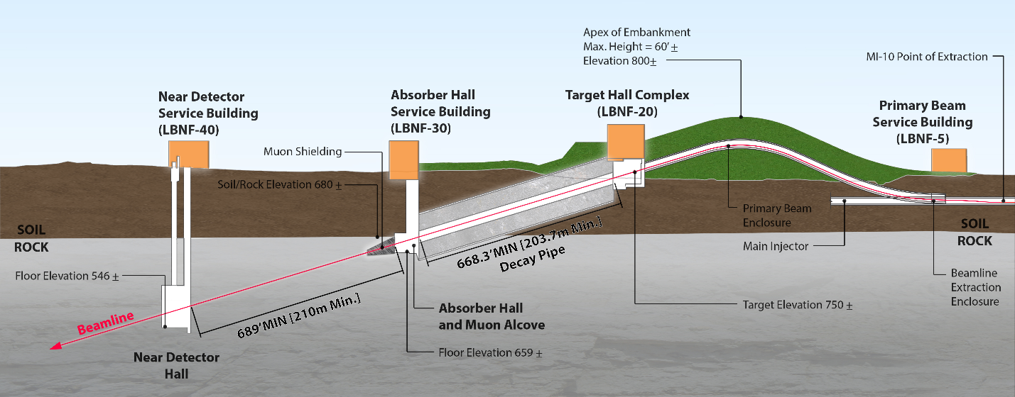
Figure 2-1: Longitudinal section of the LBNF beamline facility at Fermilab. The beam comes from the right, the protons being extracted from the MI-10 straight section of the MI.

In the reference design, the extraction of the proton beam (60 – 120 GeV) occurs at MI-10, a new installation. The extraction and transport components send the proton beam through a man-made embankment/hill whose apex is at 18.3 m from the ground and with a footprint of ~21,370 m². The beam then will be bent downward towards a target located at grade level. The overall bend of the proton beam is 7.2º westward and 5.8º downward to establish the final trajectory towards the far detector.
The general primary-beam specifications and beam characteristics are listed in Tables 2-New-1 and 2-New-2.
Table 2-1: Summary of Principal Beam Design Parameters
Parameter | Value
Protons per cycle | 7.5×10¹³
Spill duration | 1.0×10⁻⁵ sec
Energy | 60 to 120 GeV
Protons on target per year | 1.9 x 10²¹ to 1.1×10²¹
Beam/batch (84 bunches) | 8×10¹² nominal; (3×10¹¹ commissioning)
Cycle time | 0.7 to 1.2 sec
Beam Power | 1.03 to 1.20 MW

Table New-1: Beam Characteristics
Parameter | Value
Beam size at target | 1.5 to 1.7 mm
Δp/p | 11×10⁻⁴ 99% (28×10⁻⁴ 100%)
Transverse emittance | 30π μm 99% (360π μm 100%)
Beam divergence (x,y) | 17 to 15 μrad

Neutrinos are produced after the protons hit a solid target and produce mesons that are subsequently focused by magnetic horns into a 204m long decay pipe where they decay into muons and neutrinos. A wide band neutrino beam is needed to cover the first and second neutrino oscillation maxima, which for a 1300 km baseline are expected to be approximately at 2.4 and 0.8 GeV. The beam must provide a high neutrino flux at the energies bounded by the oscillation peaks and we are therefore optimizing the beamline design for neutrino energies between 0.5 and 5 GeV.

The facility is designed for initial operation at proton beam power of 1.2 MW with the capability to support an upgrade to 2.4 MW. The Beamline systems that are designed from the beginning for 2.4 MW operation include:
- The size of the enclosures (primary proton beamline, target chase, target hall, decay pipe, absorber hall)
- The radiological shielding of the enclosures, the only exception being the roof of the target hall that can be easily upgraded later for 2.4 MW
- The primary proton beamline components
- The water cooled target chase shielding panels
- The decay-pipe and its cooling and the decay pipe downstream window
- The beam absorber
- The remote handling equipment
- The RAdioactive Water (RAW) system piping

None of these can be upgraded after exposure to a high-intensity beam.
Note: According to detailed MARS simulations, 39% of the beam power is deposited to the Target Hall complex, 30% to the decay pipe region and 31% to the Absorber Hall complex.

The LBNF Beamline is being designed for twenty years of operation, while the Beamline Facility, including the shielding are planned for its entire lifetime of 30 years. A conservative stance is that for the first five years, the Beamline will operate at 1.2 MW of beam power and for the remaining fifteen years at 2.4 MW.

Scope
For organizational purposes, the LBNF beamline is broken into four principal systems:
- Beamline Management: Management and oversight, modeling effort, radiation physics and radiation protection activities
- Primary Beam: Components required for the initial, high-intensity proton beam
- Neutrino Beam: Components used to create a high-intensity neutrino beam from the initial proton beam.
- System Integration

Physics Reach with the Reference Design

The goal for accumulating 120-GeV protons at the neutrino target with beam power of 1.2 MW is 1.1×10²¹ protons-on-target (POT) per year. This assumes 7.5×10¹³ protons per MI cycle of 1.2 sec [1-POT-new] and the total LBNF efficiency of 0.56. The total LBNF efficiency used in the POT calculation and discussed below includes the total expected efficiency and up-time of the accelerator complex as well as the expected up-time of the LBNF Beamline.

The neutrino flux at the Far Detector site is shown in Figures 2-2 and 2-3, calculated for a 120 GeV proton beam, the NuMI horns at 230 kA and 6.6 m apart, and a decay distance (between horn 1 and the decay pipe) of 17.3 m. The decay pipe is 203.7 m long and 4 m in diameter.
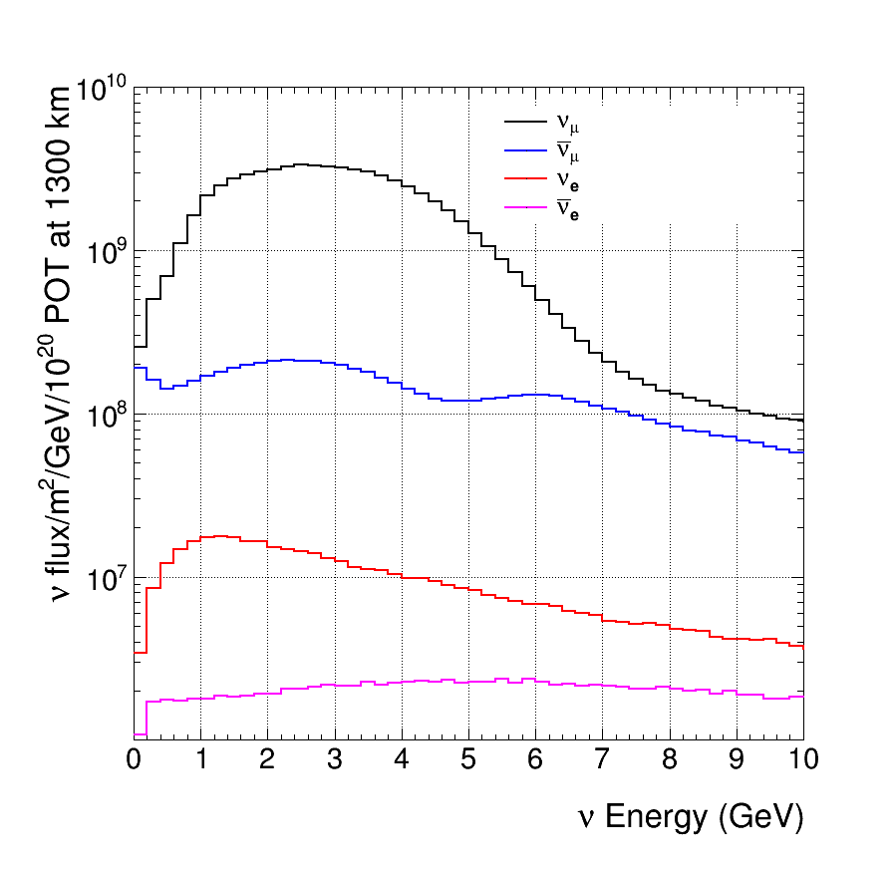
Figure 2-2: Neutrino Fluxes at the Far Detector as a function of energy in the absence of oscillations with the horns focusing positive particles. In addition to the dominant ν_{μ} flux, the minor components are also shown.
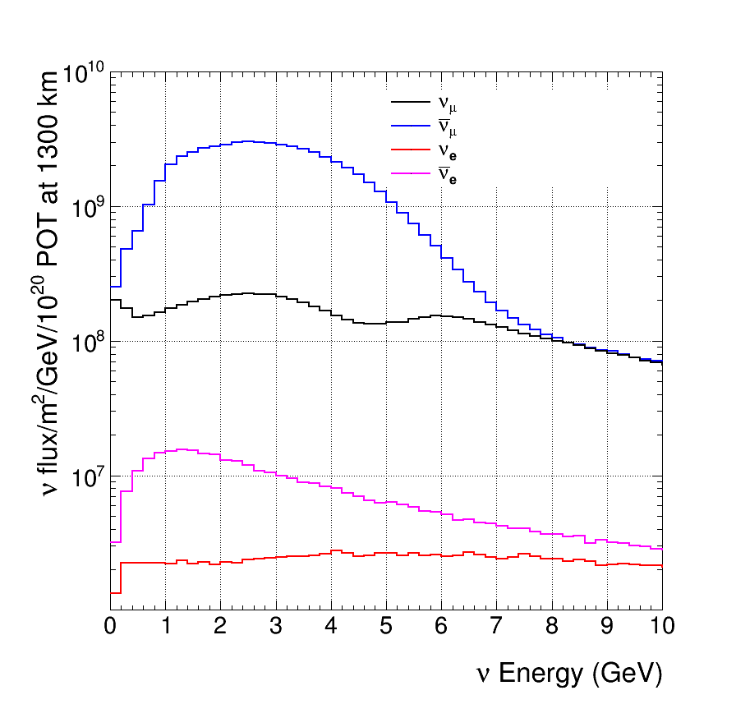
Figure 2-3: Antineutrino Fluxes at the Far Detector as a function of energy in the absence of oscillations with the horns focusing negative particles. In addition to the dominant anti-ν_{μ} flux, the minor components are also shown. Note the logarithmic scale.

Reference
For detailed information on Beamline, refer to the Annex document.

System Integration (WBS 130.02.04)

Introduction
This section covers the System Integration activity of the LBNF Beamline L2 Project. The System Integration team’s responsibilities can be broken into two major areas: first, the oversight of systems for Controls, Alignment and Interlocks, and Installation Coordination. Second, there is the task of ensuring that the interfaces between each of the subsystems of the Beamline L2 Project are complete. The Controls, Alignment, Interlocks and Installation Coordination span the entire Beamline project and must therefore be properly supported by all the interfaces in addition to the relevant components. Interface coordination involves both achieving consensus as to the location and nature of each interface and the party responsible for it. The coordination activity must also ensure proper distribution of requirements and specifications so that all the needed components are accounted for, and that they will be constructed such that they will fit together properly during installation and operate successfully.

System Integration thus has the primary responsibility of facilitating good communication throughout the L2 project to prevent deficiencies and scope-related problems, and for any that are introduced?, to spot them early on and make sure they get corrected.

Controls (WBS 130.02.04.02)

Radiation-Safety Interlock Systems (WBS 130.02.04.03)

Introduction
This section describes the philosophy, policies, procedures, design, fabrication, installation, checkout and commissioning for the Electrical Safety interlock System (ESS), Radiation Safety Interlock Systems (RSS), Radiation Monitors, Radiation Air Monitors, and Radiation Frisker Stations. Underlying all safety-system designs is a commitment to providing the necessary hardware, procedures, and knowledge to personnel to ensure their well-being. Inherent in each of these systems is the concept of redundancy.

Alignment (WBS 130.02.04.04)

Overview
This section summarizes the concepts, methodology, implementation and commissioning of the geodetic surveying (global positioning) efforts for determining the absolute positions of the LBNF beamline components at Fermilab and the location for the Far Detector at SURF. This information is critical to achieving proper aim of the neutrino beam. From this information, the beam orientation parameters are computed, as well as the alignment of the LBNF beamline.

Installation Coordination
This activity provides the management oversight of the day-to-day activities taking place in the installation areas and the framework for sequencing and scheduling the installation tasks. The scope of this role is driven by the need to balance the resources required in four distinct installation sub-projects. In addition, there is a need to ensure that all activities are conducted with a consistent level of safety and quality assurance throughout the project. The role of Installation Coordination is distinct from the actual task of installation. Its role is primarily the coordination of installation activities and will be led by an Installation Coordinator. The responsibility for the design, fabrication and installation of each element of the Beamline L2 Project resides in its appropriate subsystem.

Installation Coordination will draw on the experiences of previous installations such as NuMI, and the lessons learned from more recent installation projects such as ANU. In addition, the team will be organized in a manner that advantageously uses the project management tools being implemented throughout the laboratory. The implementation of Installation Coordination will begin with the managerial role of sequencing and controlling the activities in each of the areas (as illustrated below). Each area (e.g., Main Injector, Primary Beamline, Target Complex, and Absorber Hall) will be under the supervision of either an Operations Specialist or a Floor Manager whose job it is to oversee the overall installation activity taking place in the area and to supervise the daily activities of task managers who are leading the work crews in each area. Floor Managers will report directly to the Installation Coordinator.

Alternative Beamline Options

As discussed earlier in this CDR, the LBNF Beamline Facility is being designed for twenty years of operation with thirty years of actual lifetime. During this time period, the beam power is expected to increase from 1.2 MW to 2.4 MW and the facility must accommodate upgraded targets and horns in different configurations to maximize the neutrino flux in the appropriate energy range and to enable tunability in the neutrino energy spectrum. To allow for some flexibility and for improved capabilities in the future, the LBNF Beamline Team is investigating and considering a few alternative design options. Three of those changes affect physics and one is a technical alternative in case the current default design proves insufficient after more detailed design work. The considered alternatives are:

- A further optimized target-horn system
- A larger target chase to accommodate longer or different shape targets, and longer/wider horns possibly at a larger distance among themselves than in the current reference design
- A longer or wider decay pipe
- A gas different than air in the target chase (e.g. nitrogen or helium)

and their expected cost impacts are included in the LBNF cost range.

The reference Beamline design uses a NuMI-like target and NuMI-style horns appropriately modified for the 1.2 MW operation. Further optimization of the target-horn system has the potential to substantially increase the neutrino flux at the first and especially second oscillation maxima as well as the area in between the two maxima and reduce wrong-sign neutrino background, thereby increasing the sensitivity to CP violation and mass hierarchy determination (see discussion in Volume 2). Target R&D and target-horn optimization work is on-going and may yield further improvements beyond those currently achieved. Engineering studies of the proposed target and horn designs and methods of integrating the target into the first horn must be performed to turn these concepts into real buildable and reliable structures. These studies will be carried out between CD-1 and CD-2 to determine the baseline design for the LBNF target-horn system. In addition, since targets and horns are consumables, more advanced ones could very well be designed in the future as 2nd generation components.

The more advanced target and focusing system described in Volume 2 utilizes two horns that are longer, of larger diameter and that are spaced farther apart than in the reference design. The first horn in particular is ~ 5.5 m long and ~ 1.3 m in diameter and functions effectively as two two horns in one structure. The second horn, is NuMI-style but wider and longer, and is 7.8m farther downstream than that of the reference design. This would require a target chase approximately 9m longer and 0.6m wider than the reference design. Taking into account that the target chase cannot be expanded after construction and to sustain at 2.4 MW operation, a longer baffle and the ability to maintain a 2.5m motion flexibility for the target are essential in and out of the first horn. Additionally, the size of the target chase between CD-1 and CD-2 must be reconsidered after the target-horn optimization is complete.

The length and diameter of the decay pipe also affect the neutrino flux spectrum. A longer decay pipe increases the total neutrino flux with a larger flux increase at higher energies, while a larger diameter allows the capture and decay of lower-energy pions, increasing the neutrino flux at lower energies. The dimensions of the pipe affect some of the backgrounds. Taking into account that the decay pipe cannot be modified after the facility is built, makes the choice of geometry particularly important. The reference design values of 204 m length and 4m diameter appear well matched to the physics of LBNF [BLundberg-5024], but studies to determine the optimal dimensions will continue between CD1 and CD2. These studies will be coordinated as well with the optimization of the target and horn systems described above.

As described earlier in this CDR, the target chase is air filled and together with the surrounding target pile it is cooled by air. There are two studies in progress that could eventually determine gas selection for use in the target chase/pile cooling system: (1) the LBNF Corrosion Task Force studies that includes both measurements at NuMI and associated modeling, and (2) LBNF studies of Air Releases to the Atmosphere. The conclusion from either one or both of these studies could require that the oxygen and argon concentrations in the target pile cooling system be minimized to mitigate the possible problems of (1) corrosion due to ozone production, and/or (2) radionuclide emission to the Atmosphere. As discussed in the Neutrino Beam section of the CDR, compliance with a requirement to minimize the oxygen concentration will be accomplished by changing the cooling gas from air to nitrogen gas or possibly to helium. The conclusion of the “LBNF Beamline Air-Releases Design Review” [Air-Releases-Review] that took place in April 2015 indicates that the reference design scheme to keep air-releases under control is reasonable and with sufficient safety factor. We will need to revisit the air-releases calculations between CD-1 and CD-2 after we finalize the volumes of the target chase and decay pipe.

