Document Number | TC001TcC
Document Version | 1.0
Document Type | Test Cases for TcC 8.3 & WSS 2010
Project Name | Fermi Teamcenter PLM Deployment- Phase 1
Prepared for | Fermilab  P.O. Box 500  Batavia, IL 60510-5011  Phone: (630)-840-3000  Fax: (630)-840-4343
Contact(s) | Mr. Rich Karuhn, Service Continuity Manager  rkaruhn@fnal.gov  Mr. Tony Metz, CAD Manager  tmetz@fnal.gov
Prepared by | Siemens Product Lifecycle management Software, Inc  345 Woodcliff drive  Fairport, NY 14450
Contact(s) | Ernie Navarro  Project Manager  (585) 586-0581  ernie.navarro@siemens.com  Margaret Kubitschek  Teamcenter Architect  (304) 270-8778  margaret.kubitschek@siemens.com
Document History
Rev | Date | Change | Author
1.0 | Jun-30-2011 | Initial | Margaret Kubitschek (Siemens)  Christopher Le (Siemens)
1.1 | Jul 14,2011 | Make a template | Margaret Kubitschek
1.2 | Apr 4, 2012 | Change to match TcC Fermi Implimentation | Bob Andree

Document Reviewers

Name | Position
Ernie Navarro | Siemens PM

Final Distribution

Name | Location
Tony Metz | Fermilab

Approvals
Rich Karuhn  Fermilab, Computer Division  Service Continuity Manager | Date
Ernie Navarro  Siemens PLM Software  PM | Date

Contents

1 TcCommunity Administration 6
1.1 Site Hierarchy 6
1.3 Authentication 7
1.4 Tracking Engineering Issues 11
1.5 Visualization - SKIP 12
1.6 User Access – 14
1.7 Conferencing 15
1.8 Web Query 17

1 TcCommunity Administration

1.1 Site Hierarchy
To test whether the user is able navigate the site tree.

Step | System Steps: How To | Result / System Response | Pass/Fail
1 | Launch your preferred browser, either Internet Explorer or Mozilla Firefox |  | P
2 | Enter the Fermi URL https://intranet-int.fnal.gov/cd/sites/eea/tcc |  | P
3 | Login to Community | Login with your Services account to Sharepoint and Teamcenter | P
4 | User is presented with Home page | GUI look and feel difference 2007 and 2010 | P
5 | User is presented with options;  Shared Doucments  Teamcenter Integrations  Embedded iSeries Viewer  Product Structure Browser  Visual Issues  Requirements  Conferencing  Links |  | P
Comment |  |  | Overall: P

1.3 Authentication
Verify Single Sign On to more than one Teamcenter applicaton and secure socket layer (SSL) is configured.

1.3.1 Test whether the user is able to log into TcC application
Step | System Steps: How To | Result / System Response | Pass/Fail
1 | Launch your preferred browser, either Internet Explorer or Mozilla Firefox |  | P
2 | Enter the Fermi URL https://intranet-int.fnal.gov/cd/sites/eea/tcc |  | P
3 | Sharepoint login page is displayed and user will be asked to authenticate. User your Fermi service account and password. User will also need to log into Teamcenter with service account and password. | If the user has problems the  Button will resolve any login issues | P
4 | TcC homepage is displayed  Notice that one additional windows will launch named “Teamcenter Security Agent”  DO NOT CLOSE IT. Anytime you have these running means you can log into any Teamcenter application even via MSOffice and not be prompted for a username,password. | 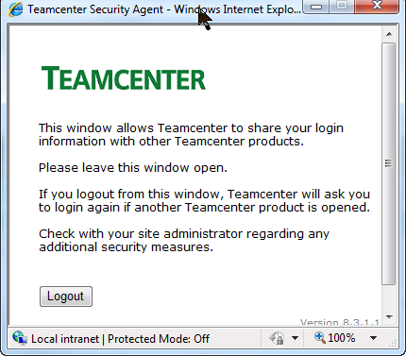 | P
Comment | Once you are logged in to Teamcenter Community if anything happens and you get this screen 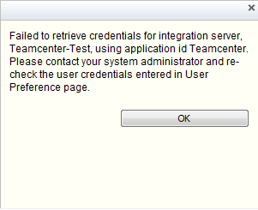 you will need to re-log in to TCC using this button |  | Overall: P

1.3.2 Test whether the user is able to log into TcUA application
Step | System Steps: How To | Result / System Response | Pass/Fail
1 | From Teamcenter Inegration area launch the Web Client and the Rich Client | 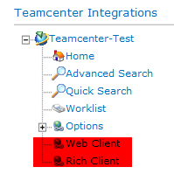 | P
2 | Click on the Rich Client item.  Login using your Fermi service username and password  Notice that two additional windows will launch, DO NOT CLOSE THEM.  “Teamcenter Security Agent” and “Teamcenter Login Successful”  Anytime you have these running means you can log into any Teamcenter application TcCommunity, TcUnified Thin Web client, 2Tier Rich client, 4Tier Rich client, and MS Office clients. |  | P
3 | Close the 4Tier Rich client |  | P
4 | Click on the Web Client item.  Notice, if you kept the “Teamcenter Security Agent” and “Teamcenter Login Successful” windows open you will not be prompted for you username or password. |  | P
Comment |  |  | Overall: P

1.4 Tracking Engineering Issues
Test visual issues creation using TcVisualization Mockup
NOTE: Mozilla Firefox is not support in the embedded viewer.
Step | System Steps: How To | Result / System Response | Pass/Fail
1 | Launch Internet Explorer. |  | P
2 | Enter the Fermi URL URL https://intranet-int.fnal.gov/cd/sites/eea/tcc/SitePages/Home.aspx |  | P
3 | Login to Community |  | P
4 | Select the Visual Issues under Lists on the Left Side | 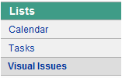 | P
5 | Under Visual Issue tabon top, Select “ Set My Default Visual Issue Location” to set it to your currnet location, Select “Configure Viewer”  Select “Open” in TcVis | 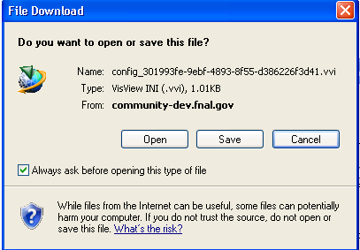 | P
6 | Open the image you want ot be associated with the Visual Issue under File/Open | 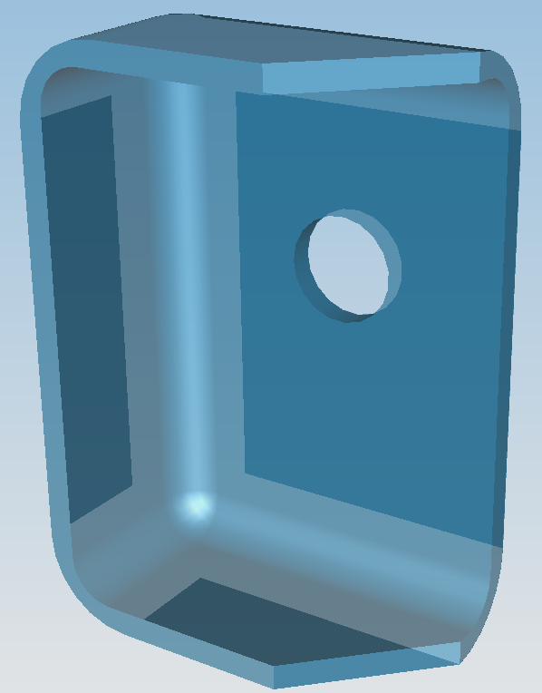 | P
7 | In TcVis, select ACTIONSISSUESADD NEW  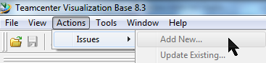 |  | P
8 | Select Issue in the Content Type 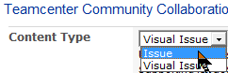 |  | P
9 | Fill in the data required |  | P
10 | Save and your Item should show in TCC |  | P
11 | Close TcVisualization |  | P
12 | Refresh the ProjectX>TcCommunity page and notice the new visual issue added. |  | P
Comment |  |  | Overall: P

1.5 Visualization - SKIP
Test whether the user is able create / join a visual conference via web part
Prerequisite: The username and workstation must have permission to download files.
Step | System Steps: How To | Result / System Response | Pass/Fail
1 | Launch Internet Explorer. |  | P
2 | Enter the Fermi URL URL https://intranet-int.fnal.gov/cd/sites/eea/tcc/SitePages/Home.aspx |  | P
3 | Login to Community |  | P
4 | Select Item in Visual Issues |  | P
5 | Under Visual Conferencing on the conferencing web part select Instant Conference ‘Launch’ link
6 | On the conference setup page enter the desired information and select OK  .  Manage Attendees: (Search contacts service name)  Conference Attachments: (no attachment)
7 | The viewer will launch and conference start
Comment |  |  | Overall:

1.6 User Access –

1.6.1 TcC User Logs into Community- SKIP SSO TURNED OFF
Test whether the user is able to log into TcC application

Step | System Steps: How To | Result / System Response | Pass/Fail
1 | Launch your preferred browser, either Internet Explorer or Mozilla Firefox |  | P
2 | Enter the Fermi URL https://intranet-int.fnal.gov/cd/sites/eea/tcc |  | P
3 | Sharepoint login page is displayed and user will be asked to authenticate. User your Fermi service account and password. User will also need to log into Teamcenter with service account and password. | If the user has problems the  Button will resolve any login issues | P
4 | TcC homepage is displayed. Welcome to Teamcenter Community Collaboration Site! |  | P
Comment |  |  | Overall:

1.7 Conferencing
Test whether the user is able create / join an appshare conference via web part

Step | System Steps: How To | Result / System Response | Pass/Fail
1 | Launch your preferred browser, either Internet Explorer or Mozilla Firefox |  | P
2 | Enter the Fermi URL https://intranet-int.fnal.gov/cd/sites/eea/tcc |  | P
3 | Sharepoint login page is displayed and user will be asked to authenticate. User your Fermi service account and password. User will also need to log into Teamcenter with service account and password. | If the user has problems the  Button will resolve any login issues | P
4 | In the right column under Conferencing – Teamcenter community collaboration  launche Appshare conference by click on the ‘Host Instant Conference’ link in the web part.  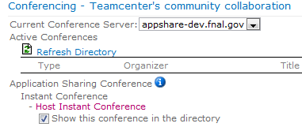 |  | P
5 | Conference manager launches, Log into Teamcenter if needed  Add attenddes by User Id |  | P
6 | Under Teamcenter Application Sharing select View/Preferences  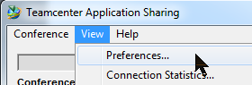 |  | P
7 | Under Authorization select Require passodr…, and enter a password for the conference  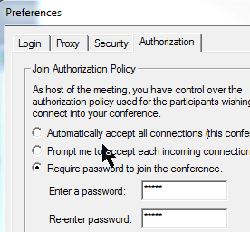 |  | P
8 | Under Login, make sure that you have selected the correct Server Name, enter your username and services password. Make sure that the Security Services is set correctly.  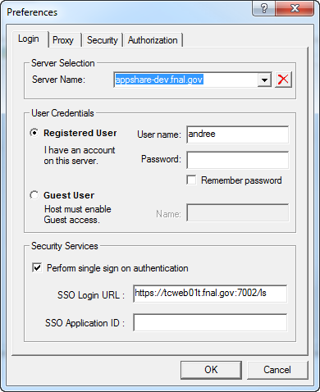 |  | P
9 | Back in the Teamcenter Community web page do a Refresh and make sure that your Quick Conference shows up  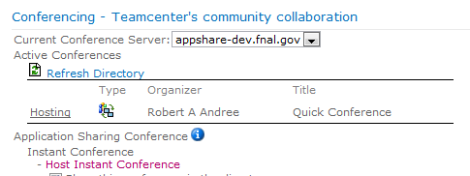 |  | P
10 | Have another user log in to TCC and the Quick Conference should show up. Have them Login and use the password you provide them. |  | P
Comment |  |  | Overall:

1.8 Web Query
Test whether the user is able view the web query portal via community

1.8.1 Web Query in TcCommunity – SKIP bug in webpart display
Prerequisite: The username and workstation must have permission to download files and make sure Tcserver is running the Tc server pool manager and weblogic.

Step | System Steps: How To | Result / System Response | Pass/Fail
1 | Launch your preferred browser, either Internet Explorer or Mozilla Firefox
2 | Enter the Fermi URL https://community-dev.fnal.gov/
3 | Login to Community
4 | Navigate to the Fermi web query community site. Go to Project X then TcCommunity page:  https://community-dev.fnal.gov/sites/projectx/tcc/default.aspx  Set your TcC Integrated Prefences.  Pull down the menu under your username in the upper right corner of the page. Select Integrated User Preferences. Select Teamcenter-Dev and enter your TcU username and password. And Save. Then Close the window.
5 | TEMPORARY WORKAROUND:  You must launch a TcU Web client first and log before proceeding. This issue has been report in IR6562953 TcU fails to launch Home link.  In the FermiLab Dev TcUA section, select the Advance Search. Pull-down the Search By list and select FNAL Released.  Verify these search properties:  Name=F*  Number=F10000001  Revision  Description  Owning User  Owning Group  Released Before  Released After | 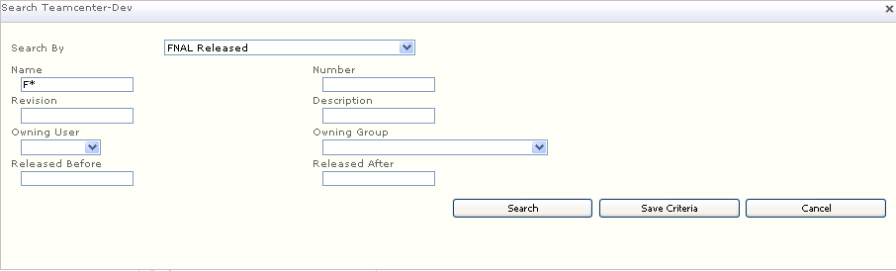
6 | Select Save Criteria and Enter FNAL Released.
7 | Now, select the new saved search under Advanced Search called, FNAL Released and the search will return results.  Verify:  Name and Revision is Ascending or Decending
8 | Double Click: F10000001/C;1-FNAL_Accumulattor, and view the .jt file, Tc Visualization.  Then close.
9 | Double Click: F100000001-C, until you see the .pdf. Open it in Adobe.  Then close..
10 | Double Click: F100000001-C, and right pull-down to open in Tc lifecycle visualization view the Sheet drawing.cgm. Open in TcVisualization.  Then close.
Comment |  |  | Overall:

